**Unit 10: Spring Mass Motion Investigation**

Goals/Rationale

The intention of this unit is to conceptually arrive at the solutions to a system of differential equations with real eigenvalues (students don’t know this, it comes later) but is motivated by the physical situation of the horizontal spring-mass system. As instructors, we know that this model for a spring-mass system is not the only system of differential equations that is important and solvable, but it works well in this unit to support student thinking of systems.

Implementation Notes for Whole Unit

This is the general vector field app. <https://ggbm.at/kkNXUVds>. It is not explicitly talked about in the materials so teachers may need to provide the link and show the students how to use it.

**Page 10.1**

Implementation Notes and Student Thinking

*Problem 1* – No differential equation is intentionally provided because students are expected to use the context to think about what types of motion are possible and then how to represent those motions in the phase plane. The intention is to engage students in making sense of the situation. Obtaining fully justified and complete (see other comments below) responses is not necessary.

Students (especially those without a strong physics background) may draw only circles and spiral type graphs (sometimes without thinking velocity is both positive and negative).

The fact that most seem to “miss” the overdamped case is not a problem. In fact, this omission actually can be good because when students encounter the overdamped case in problem x they are usually more interested in mathematically accounting for this case.

*Problem 2* - Students are not expected to derive the differential equation without significant guidance from the teacher.

One way to do this is to ask the students why the negative sign in *-kx* and *-bdx/dt* are appropriate.

Note: the second order equation needing to be derived is 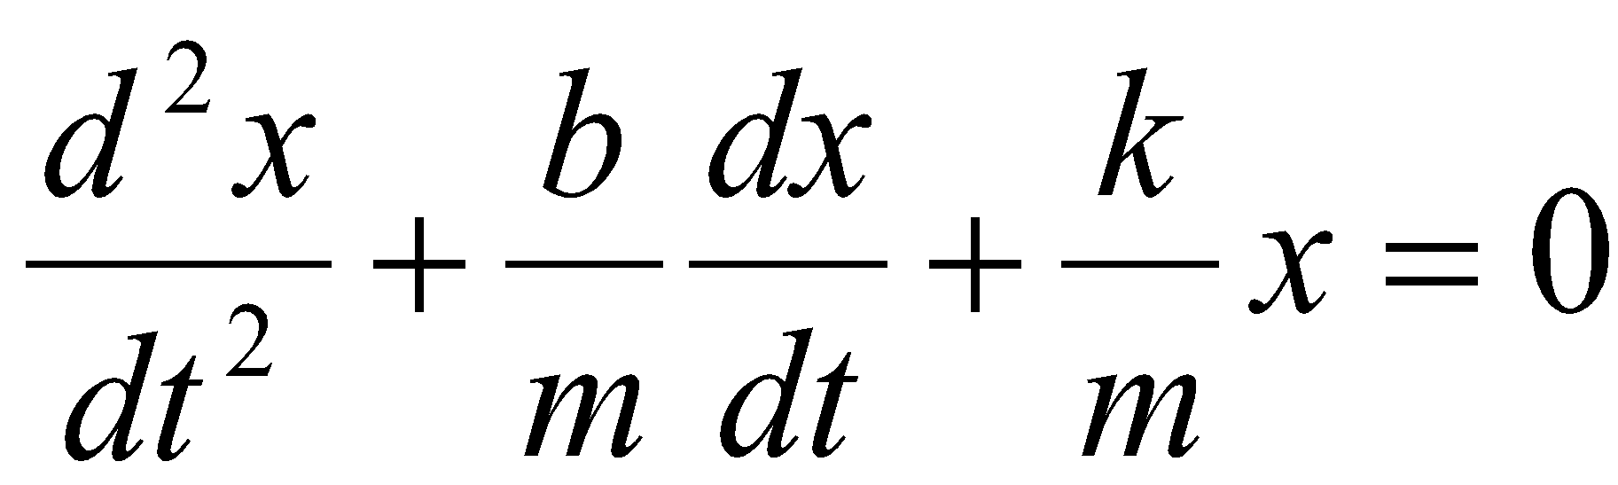, where m is mass, b is the friction coefficient, and k is the spring constant. The teacher will need to show students how to convert this to a system by defining dx/dt = v, thus yielding

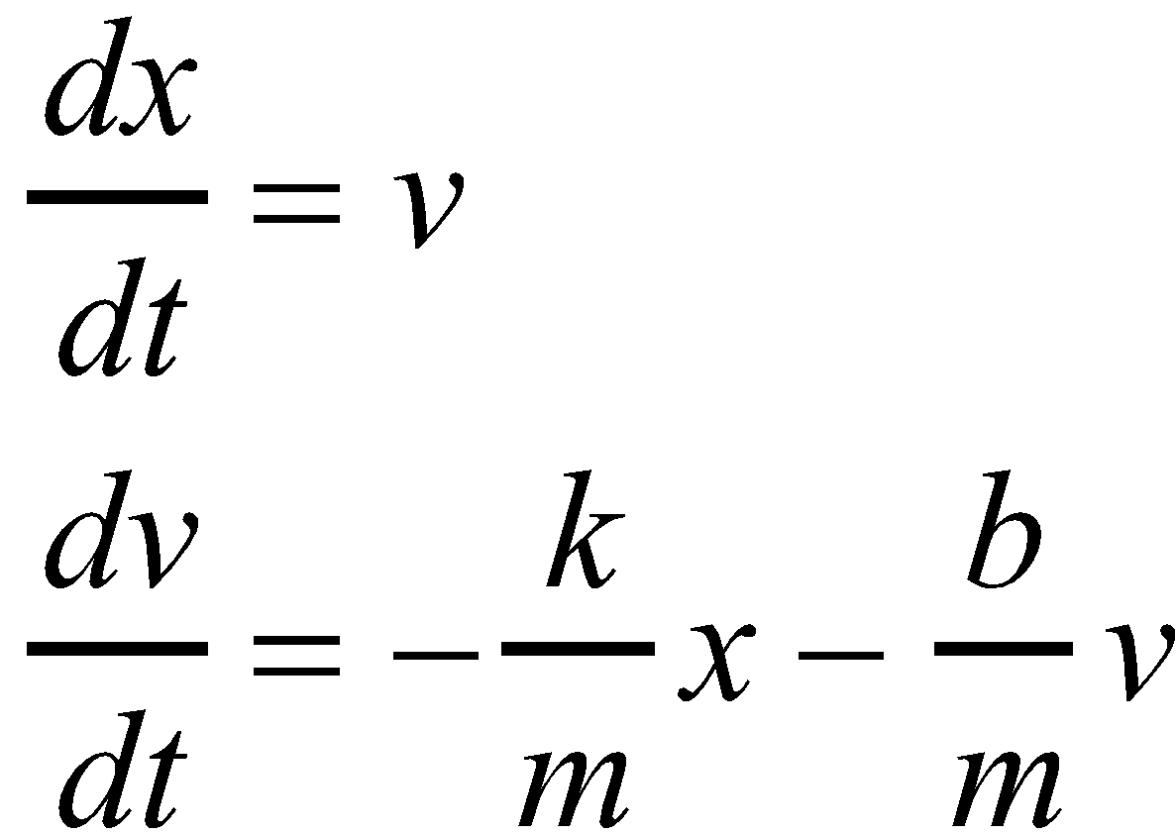

This system will be used extensively in this unit and the next.

**Page 10.2-10.4**

Implementation Notes and Student Thinking

If students are not asked to develop the notion of straight line solutions on their own, when the questions comes up on the task, they don’t get the point of why that is so important (it wasn’t motivated). So adding either a prompt the teacher says at the beginning of the unit or a small task is motivating. The instructor could use a video from online to show at the beginning of the class as the motivator of the notion of the overdamped situation which the straight line solutions represent.

*Problems 3-6 -* The purpose of problems 3-7 is to first foster a geometric and spring mass context interest in straight line solutions (overdamped case) and then to follow up this interest by algebraically determining when (if at all) and how many solutions that, when viewed in the phase plane, lie along a straight line. Conceptually, we are building up the idea of eigensolutions and eigenvectors (with eigenvalues coming later). Finding equations for solutions and hence determining eigenvalues follow in subsequent problems. A concise, jargon-free description of this sequence can be found in a Primus paper. <https://drive.google.com/file/d/0B0-hCvKlHD-uek5xcUdJeDRaQlE/view?usp=sharing>

Rasmussen, C., & Keynes, M. (2003). Lines of eigenvectors and solutions to systems of linear differential equations. *PRIMUS: Problems, Resources, and Issues in Mathematics Undergraduate Studies*, *13*(4), 308–320.

*Problem 3* - Students will come to understand that by increasing the value of the friction coefficient, the vector field (and hence solutions viewed in the phase plane) goes from closed circle-like shapes, to spiral sinks, to sinks without spirals. Students are be able to explain what these differences mean in terms of the motion of the mass. If students don't see the straight line solutions for b = 3, 3.8 it may be more apparent if they start back at b=2.3 and modify b by using the increase b button. This way, they might see the vectors rotate onto the straight line.

The intention of this problem is to foster in students a desire to know where exactly is this straight line.

Note to instructor: If you feel the need to speed up this section, you can spend little time on Problem 4, as the two main ways students solve this problem are presented in Problem 5.

*Problem 4*-6 – The students will determine an algebraic way to locate the exact slope for the apparent straight line of vectors and to determine algebraically that there are actually two different straight lines of vectors, one of which is along y=-2x and one along y=-x, neither are readily visible On the applet, students are likely to have seen and perhaps commented on y=-x, but y=-2x is indeed hard to see.. However, once you know from the algebra where to look, the presence of this straight line of vectors is more apparent.

Students will have little problem finding the line y=-x as they visually study the phase plane, but it will *be important for the instructor to push for the algebraic way to determine that this is actually the case*. The algebra will also expose y=-2x as another location for a straight line of vectors. The straight lines lie on a line with form y=mx and the slope is then y/x. Also, the slope of the vectors on the line is dy/dt/dx/dt, and this ratio can be rewritten using the actual DE equations so the two slope representations 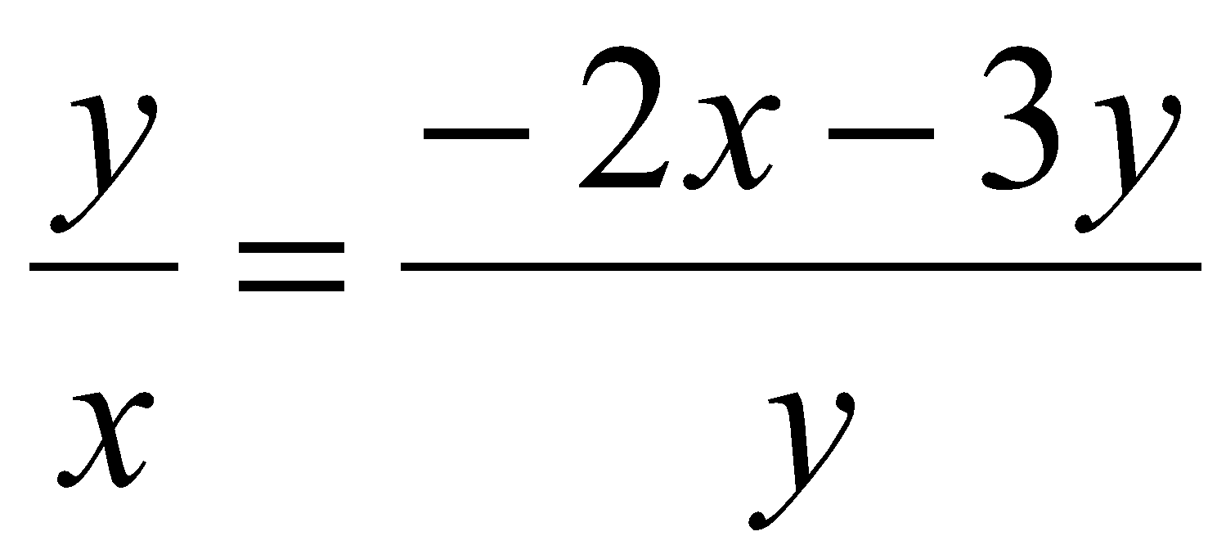 may be set equal and solved. This is a quadratic that factors as re 0 = (y+2x)(y+x), so y=-2x and y=-x. There may be other ways that the students find the straight line equation.

**Pages 10.5-10.8**

*Problems 8-11* - 3D graphs of solutions that do not look like a spiral in 3-space (either staying the same diameter, or gradually spiraling to zero is often surprising to students. The straight-line solutions are the result of the damped situation where a mass does not oscillate at all in the system, but just moves back to the zero position with a slower and slower speed. The context can help students conjecture that the 3D graph is actually more like an exponential decay.

In these sequences of problems students first figure out the x(t) and y(t) equations for solutions that, when viewed in the phase plane, lie along straight lines. They should be able to argue why such solutions are exponential functions in which the exponents for the x(t) and y(t) equations are the same (problem 9). They then figure out how to express the x(t) and y(t) equations for solution with initial condition along a straight line of eigenvectors (problems 10 and 11).

*Problems 12* - The purpose of this problem is to figure out that the x(t) and y(t) equations for a solution with initial condition not on one of the straight lines can be obtained by adding a suitable combination of straight line solutions. The given initial condition, (-4, 6) is a linear combination of the initial conditions (-2, 4) and (-2,2). Some suggestions about how to motivate this combination are given below.

Part a) – ask students to predict whether they think the graph of the solution with initial condition (-4, 6) (as viewed in the phase plane) will head toward (0,0) along a straight line or would it curve more toward the line y=-x or y=-2x. As students give reasons for their conjectures (we don’t expect them to prove their conjectures, but to develop some idea that can then be verified or refuted as the problem progresses), and when appropriate the teacher can mark on the given vector field the x(t) and y(t) equations for the initial conditions (-2, 4) and (-2,2). This not only reminds students that they already have equations for these two solutions, but makes it very tempting to add them. After students have added the equations they can then prove that this works by verifying that the combination satisfies the given differential equations (likely the teacher will have to request such verification).

Hint for students: Since we know all of the straight line solutions before Part a), the remaining solutions must bend somehow, and in fact, approach one line asymptotically

*Problem 13-* In this problem,we expect students to conjecture that you can get any solution by adding combinations of straight line solutions. Time permitting, the teacher might consider showing students how to prove this conjecture in this case. Note that in the sequence on complex eigenvalues, this conjecture is proved in general

Parts (a) and (b) require students to make connections between graphs viewed in the phase plane and 3D graphs and to explain that graphs of solutions in 3D are shifts of each other along the t-axis. The fact that in 3D graphs are shifts of each other along the t-axis makes important conceptual connections to earlier work with autonomous differential equations.

Finally, in part (c) we expect students to consider the solutions as either straight lines combinations of straight lines makes sense precisely because the graphs of the straight line solutions are shifts of each other in 3-space along the t-axis. That is, 3D graphs have a kind of structural relationship and this structure makes it reasonable to think of the space of solutions in terms of types.

Suggested question for instructor to ask the class: Why did we have to say “almost all” instead of “all?”

The teacher may want to occasionally write the x(t) and y(t) equations as vector pairs of functions as this notation is helpful and used in later problems.

Unit 10 is a long unit focused on solving this particular differential equation.  It will likely span multiple days, and the technique and importance of this first step, finding the slopes of the straight-line solutions, is likely to get lost and then forgotten.  After students have worked out the algebra to find the straight-line solutions, we recommend launching each new class meeting with a short 5-minute recap lecture that recalls the process so far.  For example, if you ended class after question 8, you might begin the next class with a lecture like: “Remember we were solving this equation, and we conjectured that there would be straight lines of the form y=ax, and we used that to set up this equation (y/x = (-2x -3y)/y or a = (-2 -3a) / a, whichever your students preferred)  to solve for the slopes of those lines.  We found a=-2, and a=-1.  Using a=-2, we set up dx/dt = y = -2x and solved for x, x = Ce^-2t, and then used y=-2x to find an equation for y=-2Ce^-2t.”  This lecture should continue to grow so that at the start of the next class to recall the beginning of the problem up through where the last class ended.

*Problem 14* - of this unit is a culminating review of the technique of finding straight line solutions to generate general solutions to systems of linear differential equations.  The system chosen here is the same as homework 2a of this unit.  How you use this task will depend on the pacing you need to set for the class, but this task is designed to facilitate student success as they approach the homework.  It is important to have a strong background on this technique so that students are more likely to be successful when approaching complex-valued slopes in the next unit.

**Notes for Personal Reflection Unit 10**